**CS5590 APS – Python – Deep Learning Programming**

**Lab 3.**

Fall 2018

UMKC

Kim-Ndor Djimadoumngar

1. **Introduction**

This is a report by Kim-Ndor Djimadoumngar for Assignment 2 of the Special Topic in Applied Programming Learning (APL) series: CS5590-0001 python and Deep Learning. My student ID is 6; my Lab ID is 7. The course is taught by Dr. Yugyung Lee and instructed by Saria Goudarzvand.

1. **Objectives**

The purposes of this lab are triple:

* To conduct Linear Regression using keras library, I used a personal dataset to perform the analyses
* To perform Logistic Regression using TensorBoard; Iris dataset was use for this purpose.

1. **Approaches/Methods**

Pycharm Community Edition 2018 was used to create Python in order to implement the exercises.

1. **Results and discussion**

**Exercise 1**

Data import, segmentation, and regularization

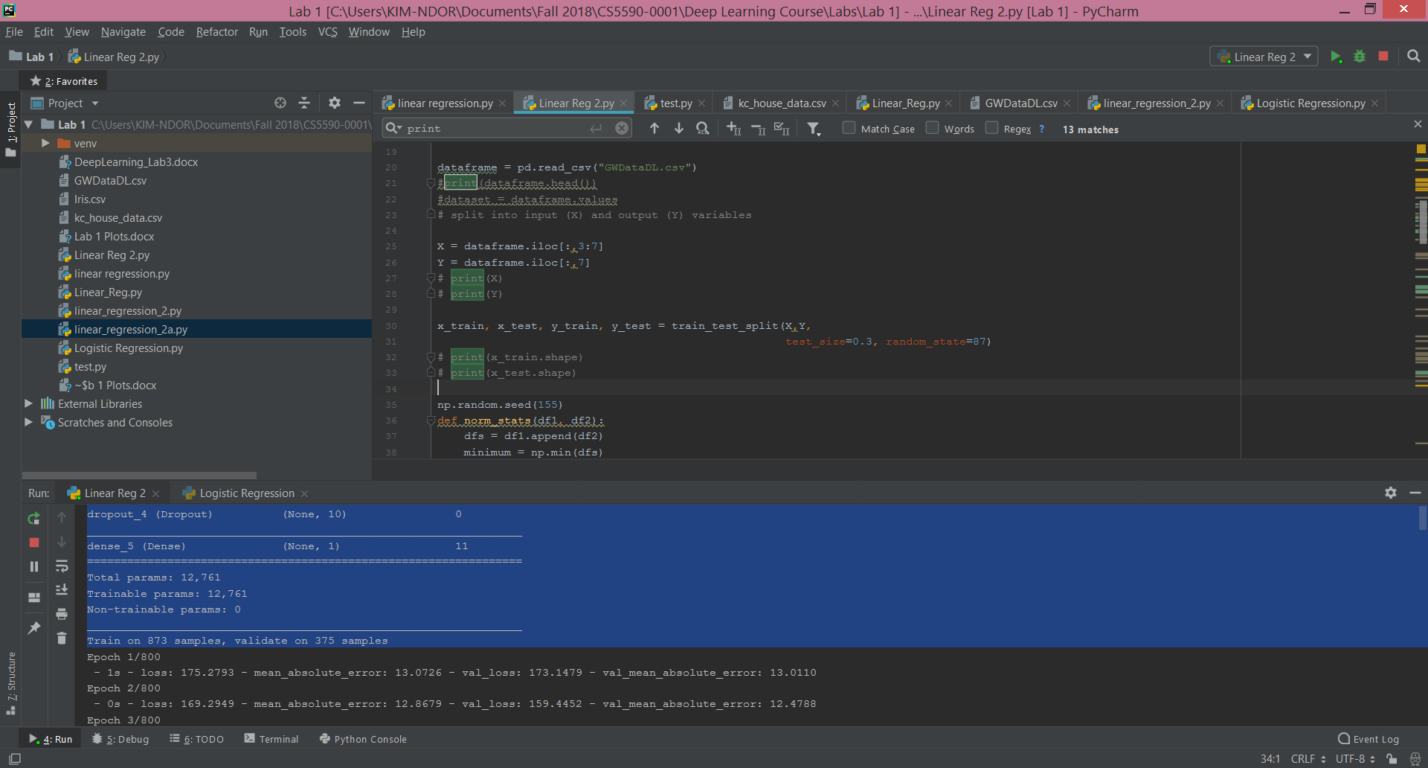

Model specification

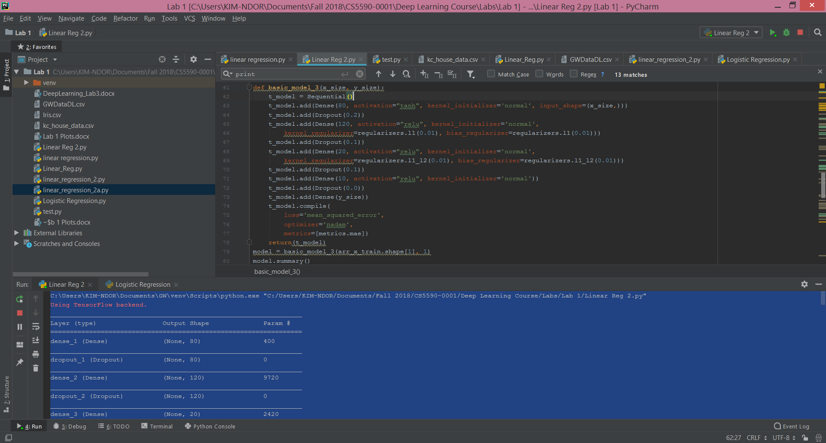

The tabular output is presented below.

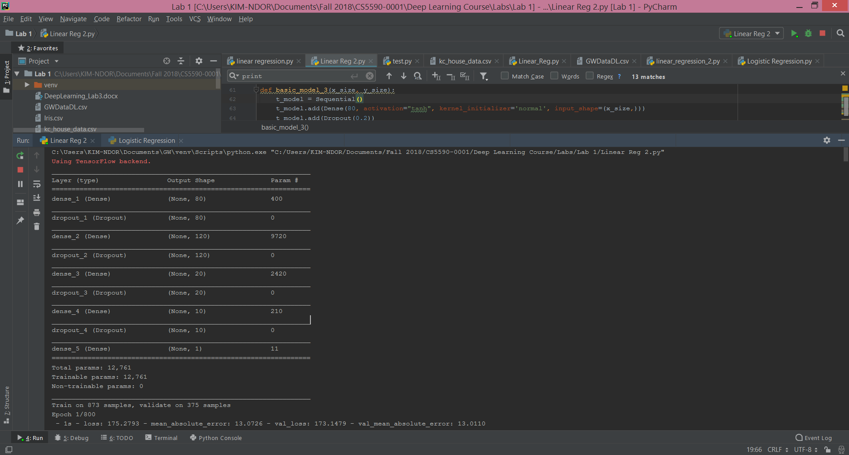

Errors results

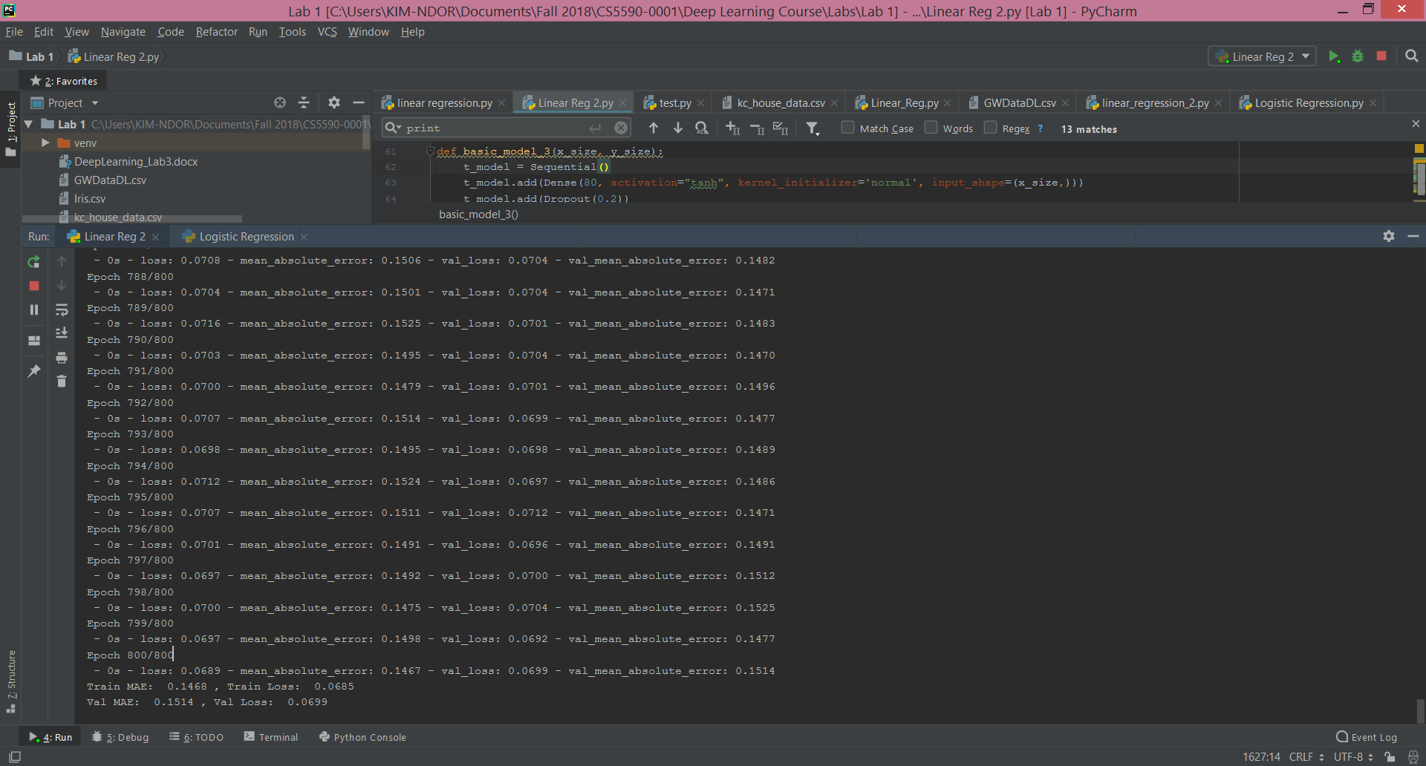

**The graph**

The codes run to produce the plot are as below.

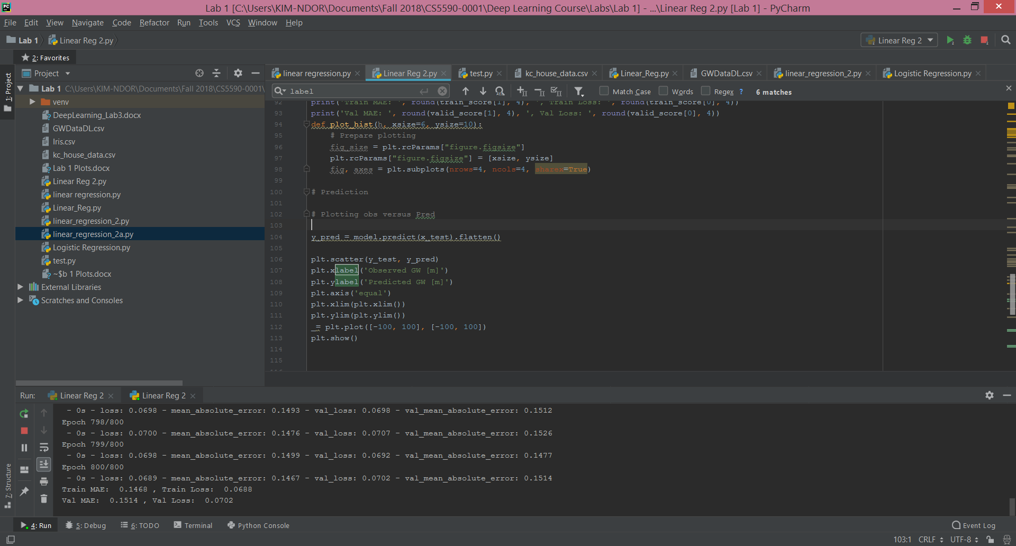

The corresponding plot is:

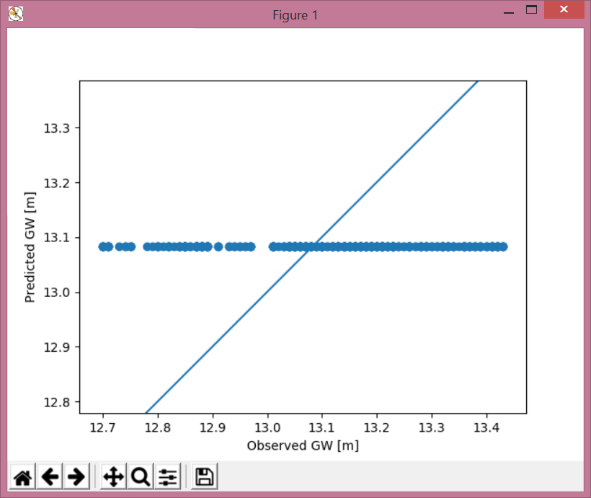

**Question b**

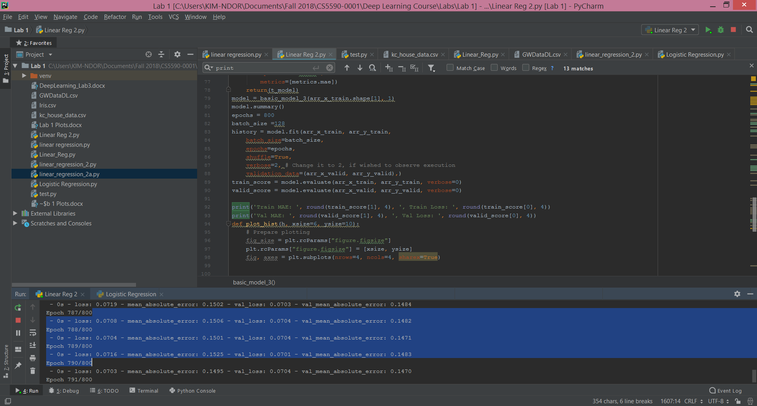

The loss plot on training and testing datasets. The loss performed better than the mean absolute error.

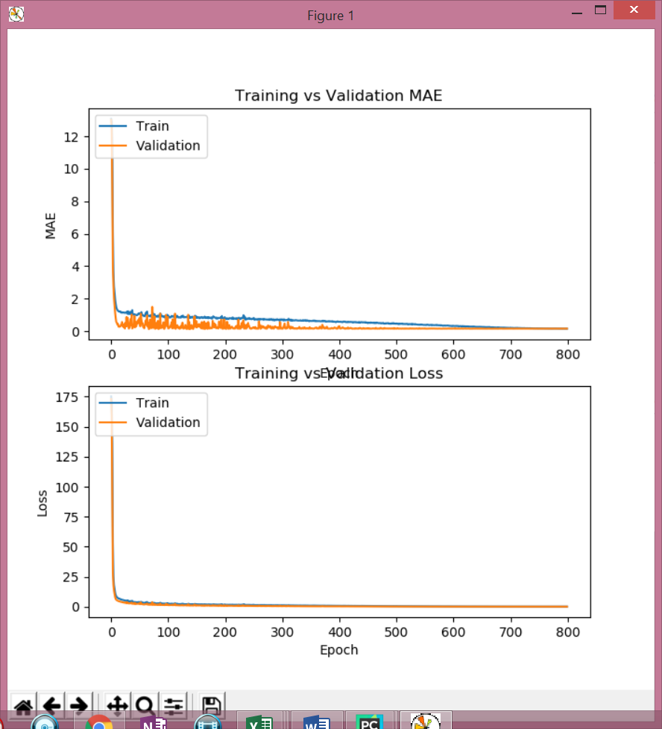

**Exercise 2**

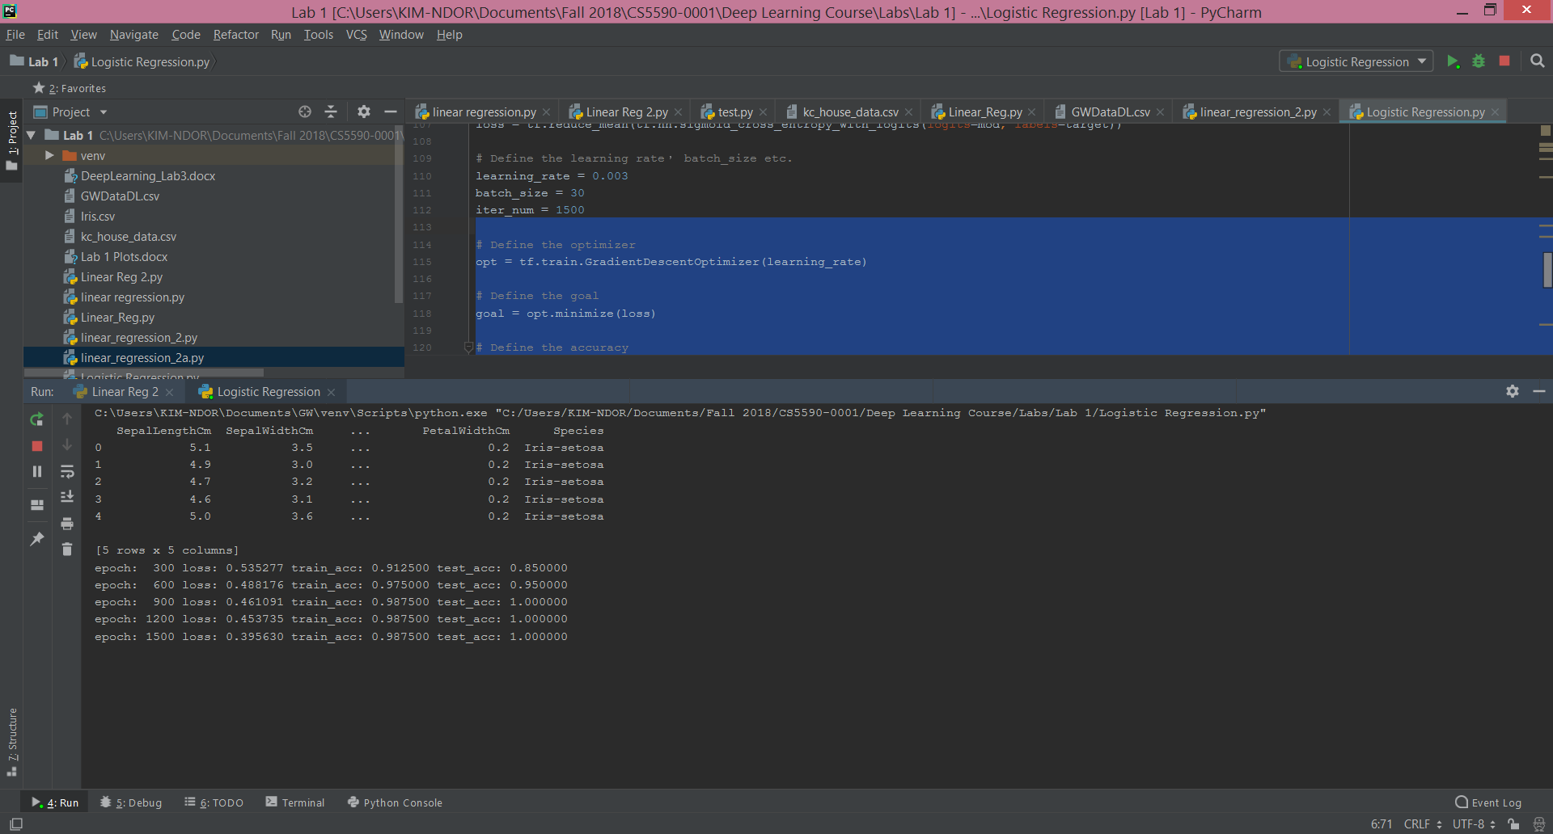

The classification plot.

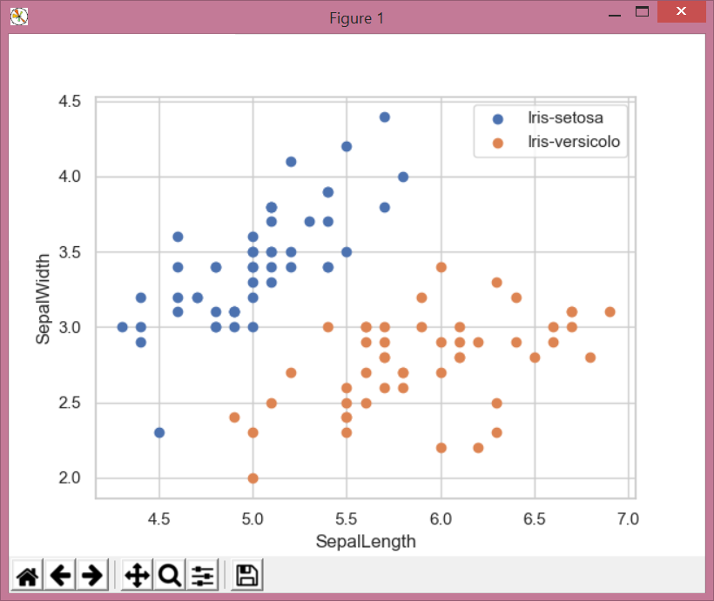

The cross entropy plot.

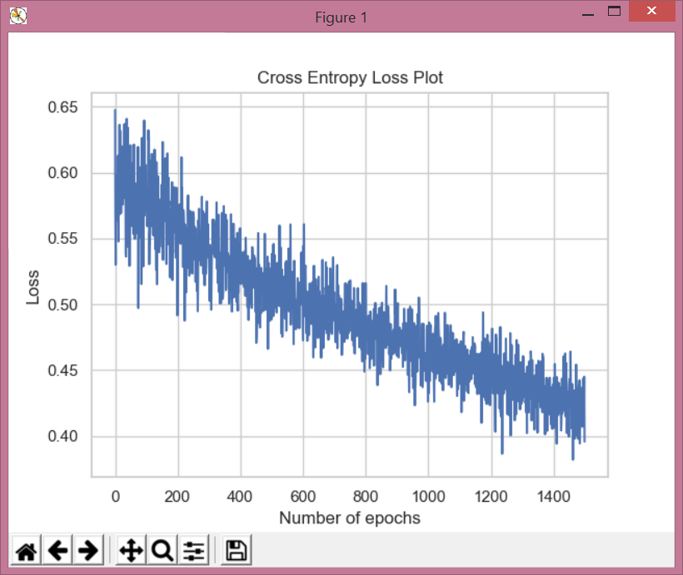

The hyperparameters.

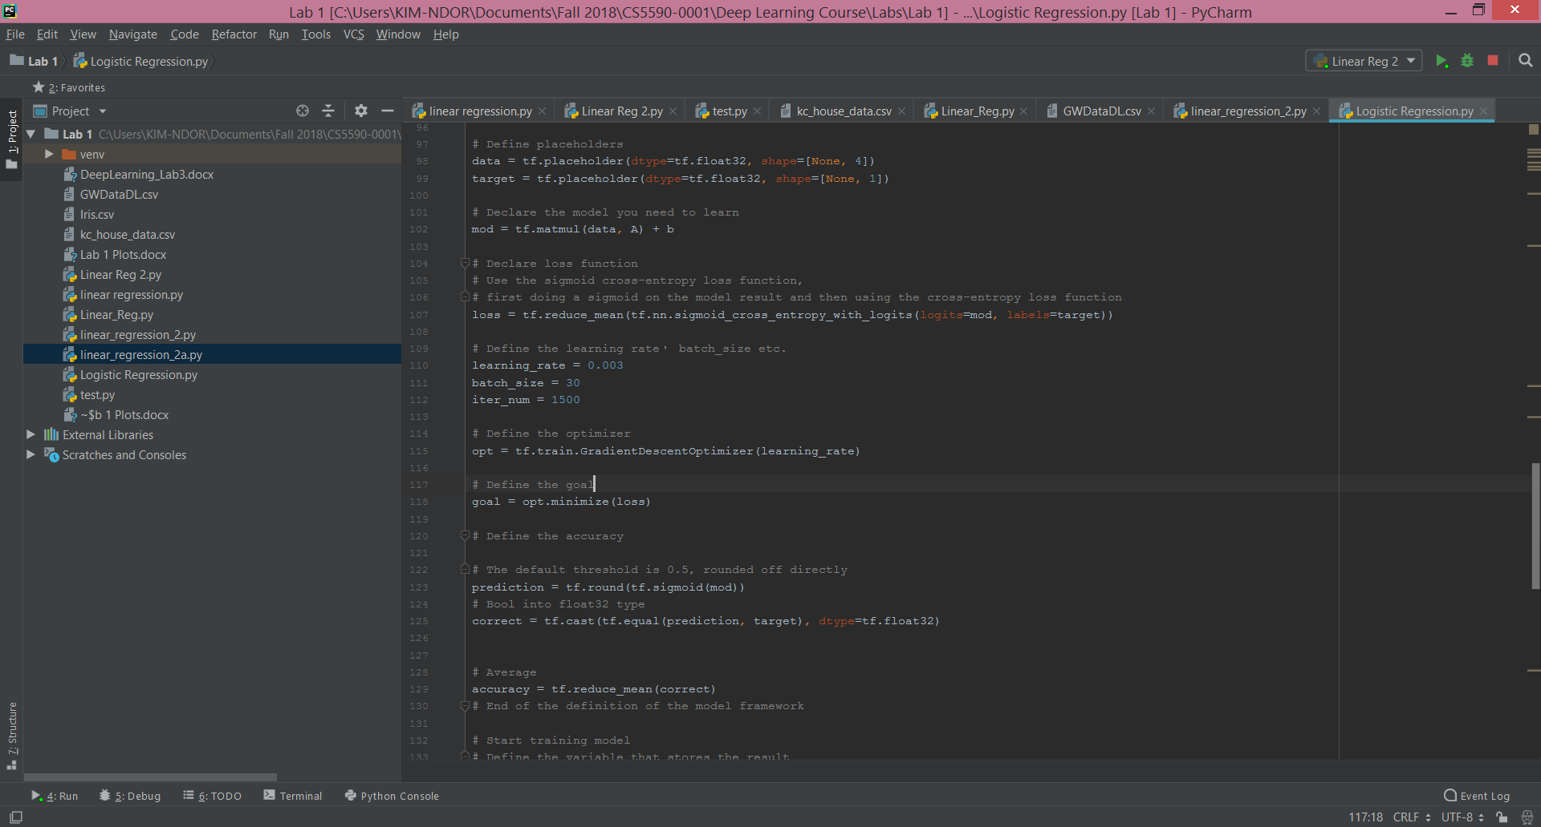

The corresponding accuracy plots.

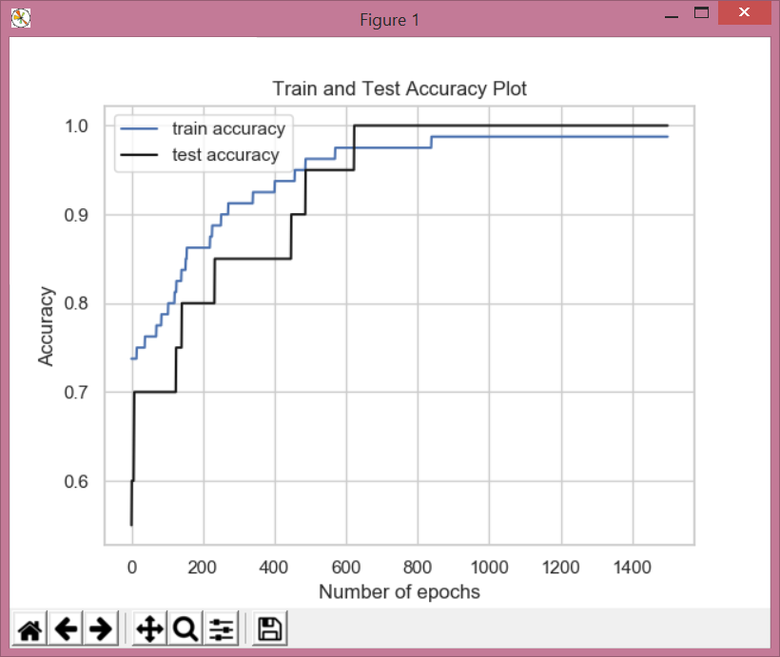

With the following hyperparameters, the entropy and accuracy decrease, as shown in the plot below.

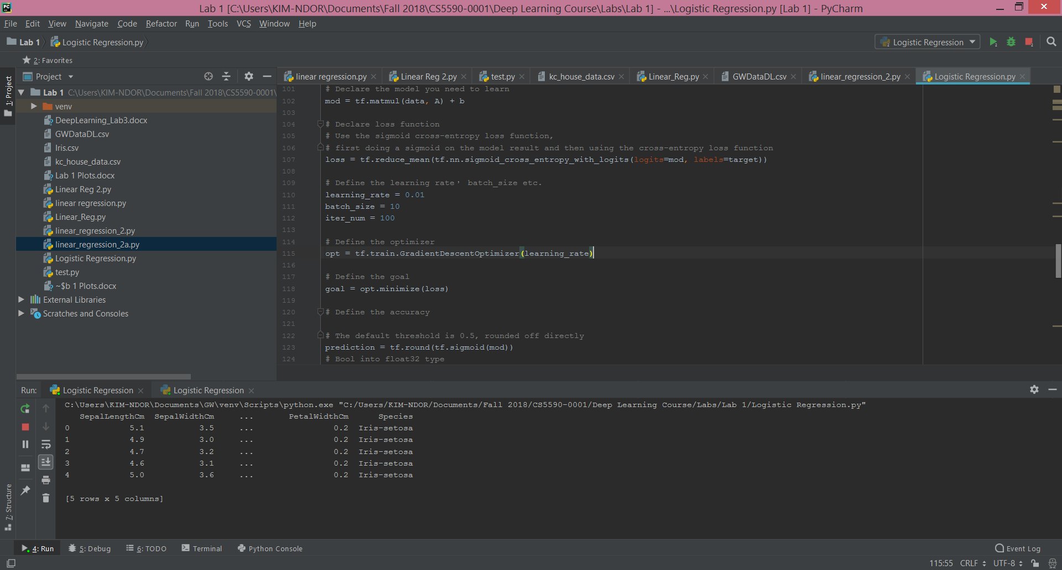

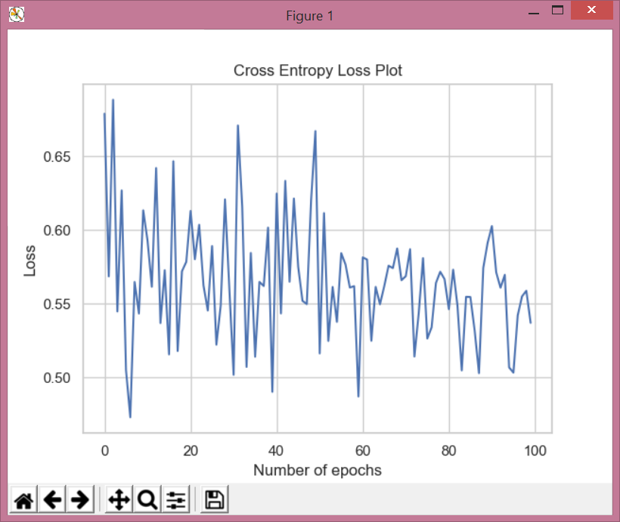

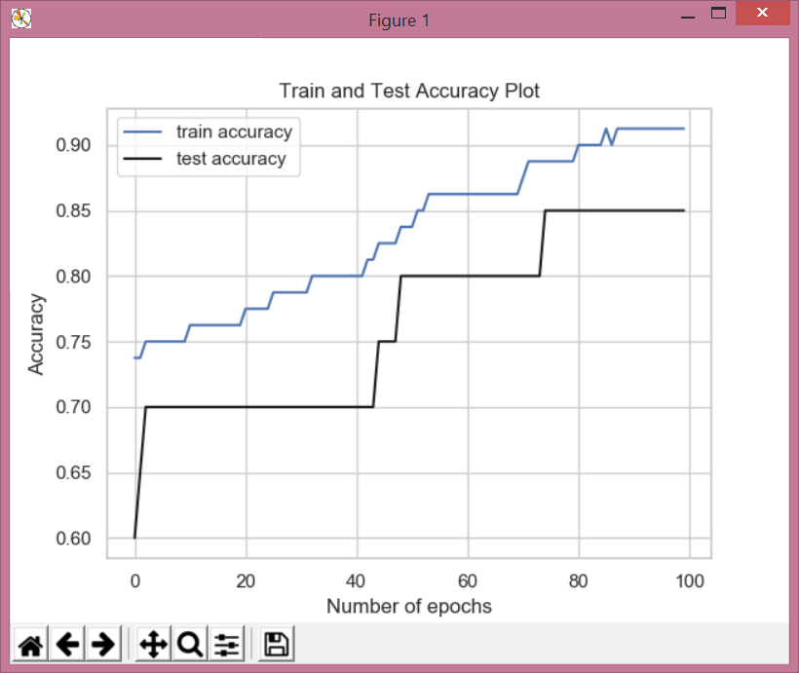

**References**

[Predict house prices: regression at](Predict house prices: regression at https://www.tensorflow.org/tutorials/keras/basic_regression)

[https://www.tensorflow.org/tutorials/keras/basic_regression](Predict house prices: regression at https://www.tensorflow.org/tutorials/keras/basic_regression) (accessed on Nov. 7, 2018).

Using Tensorflow to implement Logistic Regression model at <https://www.kaggle.com/autuanliuyc/logistic-regression-with-tensorflow> (accessed on Nov. 7, 2018).

Class materials.